NAME____________________________LAB MEETING DAY/TIME______________

Lab 10: Cenozoic Earth

In this lab you will continue to examine geologic maps and explore the Cenozoic features of the western U.S. as well as evidence of glaciations of the Pleistocene. This lab is a take-home lab, meaning you will work on the lab on your own time. Please see the Lab 10 assignment in Brightspace for details on how to complete and submit this lab.

# **Exercise 19, Part A**

**Follow the procedure on page 287 of your lab book to complete the table below. Note that the first one was done for you in the overview video.**

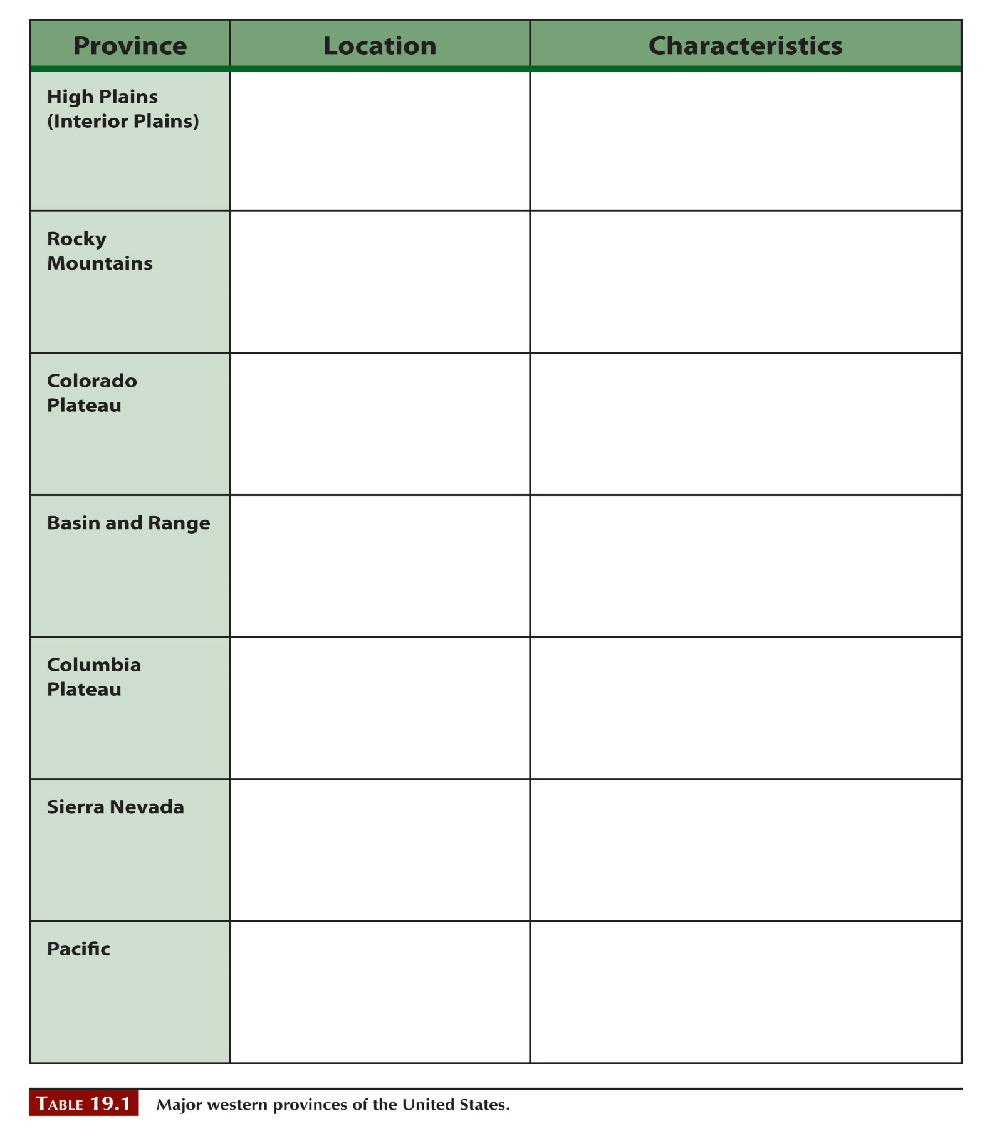

# **Exercise 19, PART B**

**Read the introduction to this activity. Be sure to watch the overview video for a discussion of the questions.**

**Question 1.**

**Question 2.**

**Question 3.**

**Question 4.**

# **Exercise 20, PART A**

**Read the introduction to this activity. Be sure you’ve watched the overview video for a discussion of this exercise.**

**Question 1.**

**Question 2.**

**Question 3.**

**Question 4.**

**Question 5.**

**Question 6.**

# **Exercise 20, PART B**

**Read the introduction to this activity. Be sure you’ve watched the overview video for a discussion of this exercise.**

**Question 1. The profiles for these questions are on the last two pages of this document.**

**Question 2.**

**Question 3. SHOW YOUR WORK**

**Question 4. SHOW YOUR WORK**

**Question 5.**

**Question 6.**

# Submitting your completed lab

* You will submit this lab through Brightspace Assignments
* Submit as a PDF with either your hand-written or typed / drawn answers.
* If you worked with others, include all names on the lab or in the submission comments.
* Name your file as TA FIRST NAME _ LAB SECTION
  + for example, Rahul_008.pdf
* Due no later than 6pm on Friday, November 17.

